**Revising the Figures 1.1.-1.3. for TOD**

Request by Jerneja, Chapter 1 for Yanina, Data Unit

28.3.2024

**Figure 1.1.**

**Figure 1.1.** Decline in biodiversity and increased participation in multilateral environmental agreements

Comments

* Figure: replace "biodiversity loss" with "nature decline"
* "Percentage of Parties in MEAs" - please include the full form of MEA
* Recommend that figure 1.1 be changed to make it easier to read. Suggest that there be only one y-axis for clarity (as both y-axis are the same), and that the y-axis labels be placed horizontally below the graph, the y-axis labels be written in black text with a colour indicator beside, and that the growth line colours have greater contrast. Also suggest to add a figure header for clarity.
* Readability of figure 1.1 could be improved, blue and green text is too small.
* The reason for this is that the MEA's do not work together to compliment each other , there is no dovetailing og Key performance indicators etc
* Figure 1.1 with MEA parties and wildlife populations is not a particularly strong substantiation of the text - easily argued potential for spurious correlation distracts from the main point the text is trying to make.

Action points

* Caption to go along the line “Wildlife population decline while stronger participation in multilateral environmental treates *as proxies for nature decline despite expansion in governance structures “*
* **Revise what is being measured**
* Instead of MEA use »multilateral environmental agreements«
* Make easier to read: only one y-axis for clarity, the y-axis labels be placed horizontally below the graph, the y-axis labels be written in black text with a colour indicator beside, and that the growth line colours have greater contrast, a figure header for clarity, text big enough, right colours…

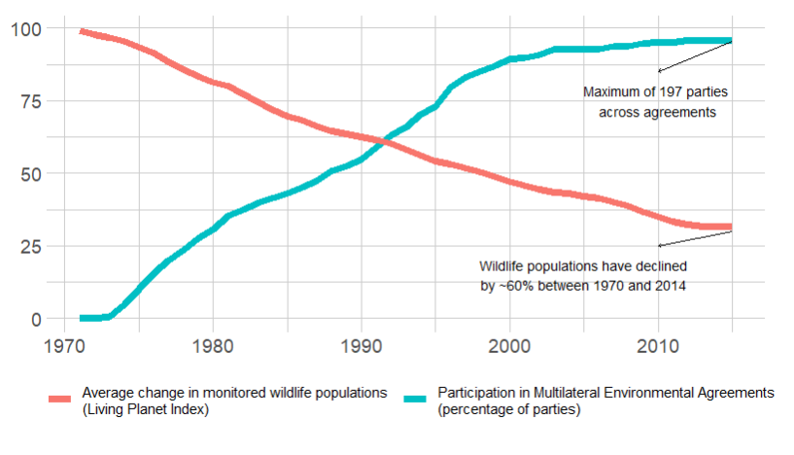

**Figure 1.2.**

**Figure 1.2.** Difference between Gross National Income and adjusted National Income growth (nature depletion).

Comments

* Recommend that figure 1.2 be changed to make it easier to read. Suggest that there be only one y-axis for clarity (as both y-axis are the same), and that the y-axis labels be placed horizontally below the graph, the y-axis labels be written in black text with a colour indicator beside, and that the growth line colours have greater contrast. Also suggest to add a figure legend for clarity.
* This graph requires a more detailed caption. It is great that there is a link to the World Development Indicators, but the landing page is one where all options are available. So information on which options were selected is needed here. Also here, the titles of the axes are in a slightly strange place and not in the middle of the axis, making it more difficult to see. The axes show the same, and therefore it would be better to just have the left axis, and have a legend underneath or next to the graph. To make it colour blind-friendly, different colours could be used or one of the lines could be dashed or dotted. It would be interesting to also have a distinction between the rich countries and the poorer countries: nature depletion is higher in the poorer countries, but they don't always benefit in equal measures. So it could be possible that rich countries get richer without much (local) nature depletion, while poorer countries don't benefit moneywise and have increased levels of nature depletion. The font could be bigger to make it more readable. The acronyms in the caption should be spelled out. There should be more details about the source: World Development Indicators (WDI, https://databank.worldbank.org/source/world-development-indicators, accessed 10.07.2023).
* It would be good to add more information on how this graph was made: on the Our World in Data website there is a graph on the number of parties in multilateral environmental agreements. Here there is a percentage in parties, were all of the ones from the Our World in Data considered? Was there a subsection? Where does the average change in monitored wildlife populations data come from? It has probably also be calculated in percentage (as it goes up to 100), but this has not been mentioned in the text. Both lines can be made with the same axis, in percentage, and then a legend on the line colours. To make it colour blind-friendly, different colours could be used, or one of the lines could be dashed or dotted. The values are scaled, so 2 axes are not necessary. Also, the website provides good information on how the data and graphs should be cited. On the website, tere are the central estimate, upper and lower estimate. It measured the change in abundance in 31,821 populations across 5,230 species relative to the year 1970 (therefore, the wildlife populations start as 100% in 1970). If possible, it would be good to have 'Percentage of parties in MEAs (in %)' and 'Average change in monitored wildlife populations (LPI) (in %) either in the middle of the axis, or closer to the start of their line. When viewed in black and white, both lines are grey, and it would be easy to think that the blue lines is the 'Percentage of parties in MEAs' because it is closely located. The font could be bigger to make it more readable. The caption of the figure should include a description of the quantitative indicators used and the acronyms should be spelled out.
* increase font size for all letters/numbers. Also, not clear what is the unit here. How many countries are considered? Or is it only the USA? Include more description in the legend. Explain GNI (abbreviation on y). Maybe instead of "current" USD, use the year to be more explicit

Action points

* Improve readability
* **Revise what is being measured 🡪 Explain better in the caption**

**Figure 1.3.**

**Figure 1.3.** The difference between explicit environmentally harmful subsidies and environmental expenditures.

Comments

* Figure 1.3 - would be better represented as a bar graph with two bars representing cumulative totals, one for each category, instead of values over time. The legend of the figure could state the timeline - this way it would likely put in evidence that not only more money was spent in harmful subsidies but also in less time than investments in nature.
* Recommend that figure 1.3 be changed to make it easier to read. Suggest that there be only one y-axis for clarity (as both y-axis are the same), and that the y-axis labels be placed horizontally below the graph, the y-axis labels be written in black text with a colour indicator beside, and that the growth line colours have greater contrast. Also suggest to add a figure legend for clarity.
* Online 412 it is stated that it is an estimation, but in the graph there are no intervals alongside the line, as it is a given number.
* The website does not provide data for before 2015, but is there a reason that additional data was not included here? Only 7 years is not so much to go by, and the environmental friendly subsidies go back to 1995.
* On the x-ax there could just be 'mean % GDP', and then a legend explaining to two different lines. To make it colour blind-friendly, the colours could be more different, or one of the lines could be dashed or dotted. The font could be bigger to make it more readable. The values are scaled, so 2 axes are not needed. The Caption of the figure should be: Comparison between government expenditures on environmental protection and explicit environmentally harmful subsidies (EHS, government subsidies related to fossil fuels like coal, natural gas, petroleum and electricity). The pointed line indicates the beginning of projected trends. Source: International Monetary Fund on Government Policy Indicators (https://climatedata.imf.org/pages/go-indicators#gp3, accessed 10.07.2023).
* Please improve all your plots. Their overall look (the ones in this chapter) are very elementary, and the timeline needs an update as you may see a spike in the last couple of years as more studies become available.
* increase font size for all letters/numbers, explain abbreviation on y axis. Explain scale n = how many countries?

Action points

* Improve readability
* Could we add to the legend of the figure the timeline – so that it would put in evidence that not only more money was spent in harmful subsidies but also in less time than investments in nature?
* Simplify x and y axis
* How could we indicate that this is an estimation? In the graph there are no intervals alongside the line, as it is a given number.
* Could we add data before 2015?
* Change caption into “*Comparison between* government expenditures on environmental protection and explicit environmentally harmful subsidies (EHS, government subsidies related to fossil fuels like coal, natural gas, petroleum and electricity)”

All figures

* Font size big enough, colour blind adjusted etc.